DEPARTMENT OF COMPUTER SCIENCE & ENGINEERING – ARTIFICIAL INTELLIGENCE & MACHINE LEARNING
ABES Engineering College, Ghaziabad
SOFTWARE REQUIREMENTS
SPECIFICATION (SRS)
Project Title: HealthAI – AI-Based Heart Disease Risk Assessment System
Standard Academic Compliance: IEEE Std 830-1998
————————————————————————————
SUBMITTED BY:  Ansh Goel (Roll No: 2400321530038)  Degree: Bachelor of Technology (B.Tech)  Academic Year: 2026 – 2027  Status: 3rd Year Project Specification  Date of Submission: 01-10-2026 | UNDER THE GUIDANCE OF:  Project Guide: Aaditya Kumar  Mentor

1. Introduction
1.1 Purpose
The purpose of this Software Requirements Specification (SRS) is to define the functional and non-functional requirements of HealthAI, an AI-based heart disease risk assessment application. The document describes the implemented user interface, health-data inputs, machine-learning inference process, result visualization, session-based result storage, PDF report generation, operating environment, constraints, and system analysis models. It provides a common reference for project development, academic evaluation, testing, and demonstration.
1.2 Scope of the System
HealthAI is a self-contained Streamlit application that accepts selected heart-health attributes from a user and applies a trained machine-learning pipeline to produce an estimated heart-disease class and positive-class probability. The system is intended for informational and educational use and does not provide a medical diagnosis.
- In-Scope Capabilities: Dashboard and navigation; capture of 11 model input features; input validation through Streamlit controls; loading of the serialized trained model; preprocessing and prediction; probability visualization through a Plotly gauge; display of the entered information; session-based storage of the latest result; and downloadable PDF assessment reports.
- Out-of-Scope Boundaries: User accounts or authentication; administrator workflows; persistent database storage; external REST APIs; online payment processing; IoT or medical-device integration; automatic collection of clinical data; and diagnosis or treatment recommendations.
- Expected Benefits: A simple interface for entering relevant heart-health attributes, consistent execution of the trained ML pipeline, an immediately understandable estimated result, session-level review of the latest assessment, and a structured PDF report that can be saved for reference.
1.3 Definitions, Acronyms, and Abbreviations
Framework | Streamlit | Python framework used to build and run the interactive web application.
ML | Machine Learning | Computational approach used to learn a classification model from the heart-health dataset.
Model | Gradient Boosting | The classifier used in the final trained inference pipeline.
Preprocessing | One-Hot Encoding | Encoding used for categorical input features in the final preprocessing pipeline.
Preprocessing | StandardScaler | Scaling step used for numerical features in the final preprocessing pipeline.
Evaluation | ROC-AUC | Model evaluation metric used in the notebook during model comparison and cross-validation.
Reporting | PDF | Portable Document Format report generated with ReportLab from the latest assessment.
1.4 References
- IEEE Std 830-1998: IEEE Recommended Practice for Software Requirements Specifications.
- Project Source Files: HealthAI Streamlit application (app.py), HealthAI(4).ipynb model-development notebook, Heart_report.csv dataset, and heart_disease_model1.pkl serialized model supplied with the project.
- Software Libraries Used in the Implementation: Python, Streamlit, pandas, scikit-learn, Plotly, joblib, and ReportLab, as reflected in the project source files.
1.5 Document Overview
Section 2 describes the product perspective, users, operating environment, constraints, assumptions, and dependencies. Section 3 defines functional requirements for navigation, data entry, ML inference, result visualization, session results, and PDF reporting. Section 4 specifies the user, hardware, software, and communication interfaces. Section 5 defines non-functional requirements. Section 6 presents the system architecture, use-case view, and assessment flow. Section 7 provides the academic review and sign-off area.

2. Overall Description
2.1 Product Perspective
HealthAI operates as a lightweight presentation-and-inference application. A user interacts with the Streamlit web interface through a browser. The application creates a single-record input DataFrame containing the 11 original model features and passes it to the serialized scikit-learn pipeline. The deployed pipeline performs the required preprocessing and invokes the Gradient Boosting classifier. The application then presents the predicted class and positive-class probability, stores the latest result in Streamlit session state, and can generate a PDF report using ReportLab. No persistent application database is used.
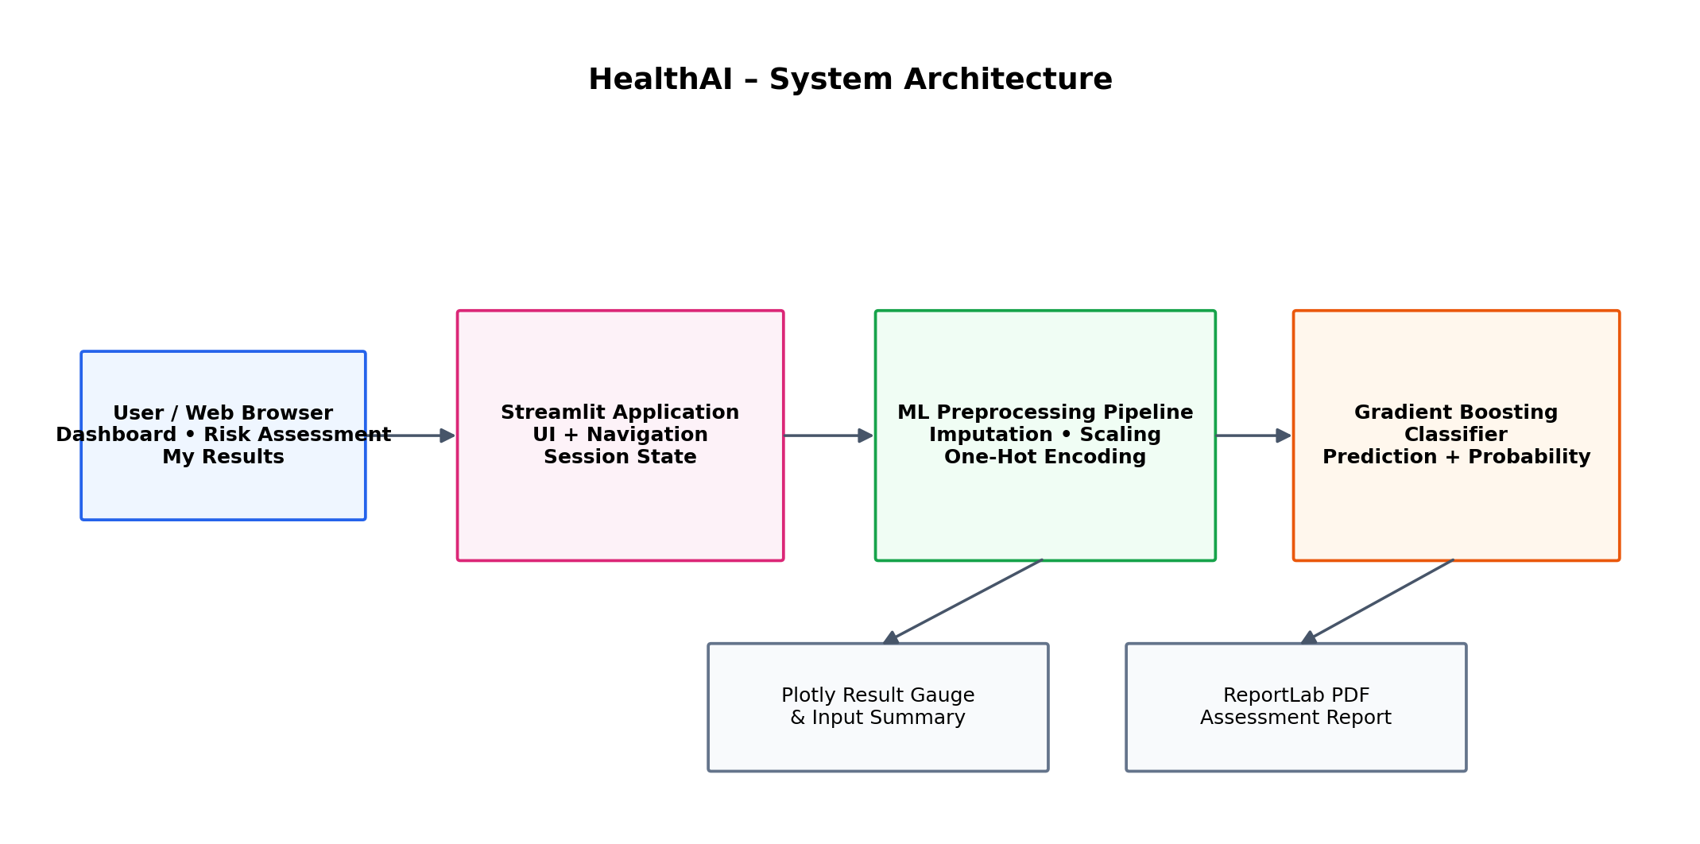
Figure 1. HealthAI system architecture.

2.2 User Classes and Characteristics
The implemented system has one primary operational user class. A project developer/maintainer may operate the application environment, but there is no separate administrator interface in the software.
End User | Basic to Intermediate | Open the application, navigate the dashboard, enter health attributes, submit an assessment, view the estimated result and probability, review the latest session result, and download the PDF report.
Developer / Maintainer | Intermediate to Advanced | Install dependencies, place the compatible model artifact in the expected path, run the Streamlit application, maintain the source code, and replace/retrain the model when required. No separate admin UI is provided.
2.3 Operating Environment
HealthAI requires a Python environment capable of running the Streamlit application and its installed dependencies. It is accessed through a modern web browser. The trained model file must be available at the application path expected by app.py. The project was developed and tested as a Python/Streamlit application and is suitable for execution on a standard desktop or laptop environment.
- Client Requirements: Modern web browser with JavaScript enabled; keyboard, mouse/trackpad, and display suitable for the Streamlit interface.
- Application Runtime: Python with Streamlit, pandas, joblib, Plotly, scikit-learn and ReportLab packages installed. The exact package versions should match the environment used to create the serialized model where required.
- Model/Data Files: heart_disease_model1.pkl for inference and the project dataset/notebook for model-development and reproducibility purposes. The deployed application does not require a database server.
2.4 Design and Implementation Constraints
- Model Input Constraint: The inference pipeline expects the following 11 original input columns in the application: Age, Sex, ChestPainType, RestingBP, Cholesterol, FastingBS, RestingECG, MaxHR, ExerciseAngina, Oldpeak, and ST_Slope.
- Application Constraint: Results are stored only in Streamlit session state. The implemented application does not provide persistent patient records, login accounts, or a database.
- Safety Constraint: The displayed result is an ML estimate based on the supplied inputs. The application must clearly state that it is not a medical diagnosis and must not be presented as a replacement for professional medical advice.
2.5 Assumptions and Dependencies
- Assumptions: Users enter values that correspond to the requested health measurements and categories. Where applicable, the user has access to recent or reliable health-report values for measurements such as blood pressure, cholesterol, ECG category, maximum heart rate, and ST depression.
- Dependencies: Availability of the serialized model file; compatible Python/scikit-learn runtime; required Streamlit, pandas, Plotly, joblib and ReportLab packages; and a browser capable of displaying the Streamlit application.
3. System Features and Functional Requirements
The following requirements describe the functions implemented in the current HealthAI application. Requirement identifiers are grouped by functional module.
3.1 Module 1: Navigation and Dashboard
FR-1.1 | Dashboard Display | System shall display the HealthAI dashboard with an overview of the assessment and a start-assessment action. | High
FR-1.2 | Sidebar Navigation | System shall provide navigation to Dashboard, Risk Assessment and My Results. | High
FR-1.3 | Start Assessment | Selecting the dashboard start action shall navigate the user to the Risk Assessment page. | Medium
3.2 Module 2: Health Data Capture and Validation
FR-2.1 | Capture Health Attributes | System shall capture Age, Sex, ChestPainType, RestingBP, Cholesterol, FastingBS, RestingECG, MaxHR, ExerciseAngina, Oldpeak and ST_Slope. | High
FR-2.2 | Input Range Controls | Age, blood pressure, cholesterol, maximum heart rate and Oldpeak shall be collected through bounded numeric controls; categorical fields shall use predefined select-box values. | High
FR-2.3 | Feature Schema Integrity | The application shall create the model input using the exact 11 original feature names expected by the deployed pipeline. | High
FR-2.4 | Guidance for Health Values | The interface shall provide contextual help and instruct users to use accurate/reliable health-report values where available. | Medium
3.3 Module 3: ML Inference, Results and Reporting
FR-3.1 | Load Trained Model | System shall load the compatible serialized HealthAI model artifact using joblib when the application starts. | High
FR-3.2 | Generate Prediction | System shall pass the 11-feature input record to the loaded pipeline and return the predicted heart-disease class. | High
FR-3.3 | Generate Probability | When the loaded model supports predict_proba, system shall obtain the probability associated with class 1 and display it as a percentage. | High
FR-3.4 | Result Visualization | System shall display the assessment class, probability gauge and input summary using the Streamlit/Plotly interface. | High
FR-3.5 | Session Result | System shall store the latest prediction, probability and input DataFrame in Streamlit session state for the My Results page. | Medium
FR-3.6 | PDF Report | System shall generate a downloadable PDF containing the assessment result, probability, entered values and safety disclaimer. | Medium
FR-3.7 | Error Handling | If model loading or assessment execution fails, the application shall display an error message and relevant diagnostic information rather than silently failing. | High
4. External Interface Requirements
4.1 User Interfaces (UI)
The interface provides a sidebar with Dashboard, Risk Assessment, and My Results navigation. The Dashboard explains the assessment process and provides a start button. The Risk Assessment page collects the 11 model inputs using number inputs and select boxes. The result area displays the estimated class, probability gauge, and entered information. The My Results page shows the latest result from the current session and provides the PDF report download.
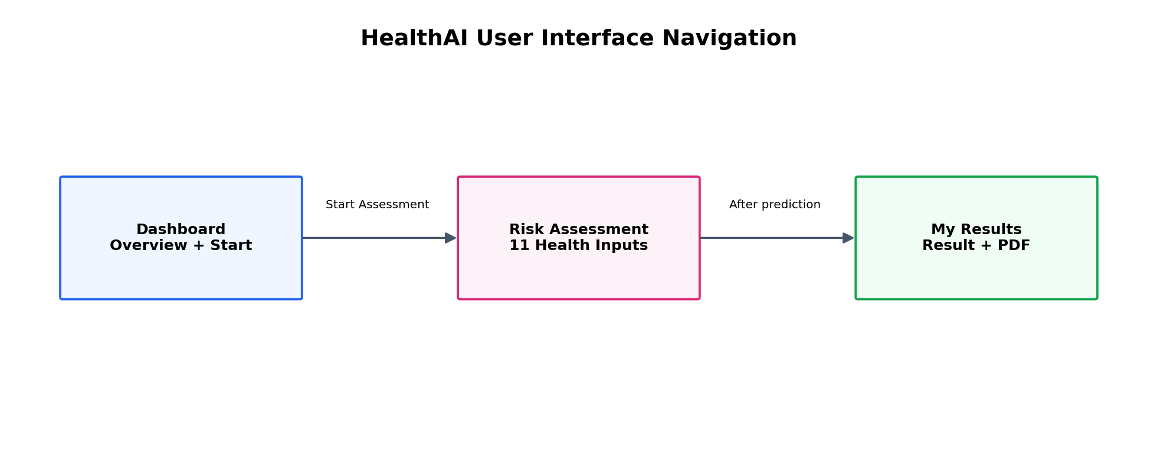
Figure 2. Implemented HealthAI navigation flow.

4.2 Hardware Interfaces
No dedicated hardware interface is implemented. The system uses standard computer input/output devices.
- Standard Hardware: Desktop or laptop processor, memory, display, keyboard and pointing device sufficient to run a web browser and the Python/Streamlit application.
- Medical/IoT Hardware: No direct connection to ECG devices, sensors, wearables, microcontrollers, or other medical hardware is implemented.
4.3 Software Interfaces
- Streamlit provides the application UI and execution framework; pandas creates the single-record input DataFrame; joblib loads the serialized machine-learning pipeline; scikit-learn performs preprocessing and Gradient Boosting inference; Plotly renders the probability gauge; and ReportLab generates the PDF report.
- No relational database, ORM, external cloud storage service, authentication provider, or external REST API is used by the implemented application.
4.4 Communication Interfaces
- The application is accessed through a web browser using the communication mechanism provided by the Streamlit runtime. When deployed remotely, normal browser-to-server HTTP/HTTPS communication is used. The application does not define a custom REST API or external data-exchange protocol.
- The system exchanges the assessment values internally as a pandas DataFrame and passes them to the loaded scikit-learn pipeline. PDF output is generated locally by the application and returned to the browser as a downloadable file.
5. Non-Functional Requirements (NFRs)
5.1 Performance | Assessment should execute interactively for a single user input on the supported runtime; no batch-processing requirement exists. | Run the application locally/deployed and measure time from submission to displayed result under normal conditions.
5.2 Security & Privacy | Do not request or display unnecessary personally identifiable information. No passwords or persistent patient records are stored by the application. | Review source code, UI fields, session state and generated report content; confirm no authentication/database component is present.
5.3 Reliability | Application shall handle model-load and prediction exceptions with visible error messages. The compatible model artifact must be present for successful startup. | Test startup with missing/incompatible model and test valid/invalid runtime conditions.
5.4 Usability & Portability | Interface shall remain understandable across common desktop browser sizes and use standard Streamlit controls for navigation and input. | Manual UI inspection in supported modern browsers and desktop viewport sizes.
5.5 ML Quality Baseline | The notebook evaluates candidate classifiers using 5-fold stratified cross-validation. The selected Gradient Boosting pipeline achieved mean CV Accuracy 0.8638, Precision 0.8628, Recall 0.8997, F1 0.8801 and ROC-AUC 0.9222 in the recorded experiment. | Re-run the notebook with the project dataset and compare the cross-validation metrics with the recorded baseline.

Model-development note: The supplied notebook uses an 80/20 stratified train-test split and also evaluates candidate models with 5-fold stratified cross-validation. The final deployed pipeline uses numerical imputation with median strategy, standard scaling, categorical imputation with most-frequent strategy, one-hot encoding, and a Gradient Boosting classifier.
6. System Design and Analysis Models
The following models describe the implemented HealthAI system. Because the application has no persistent database, an Entity-Relationship Diagram is not applicable to the current implementation.
System Architecture | Shows the browser, Streamlit application, ML preprocessing pipeline, Gradient Boosting classifier, result visualization and PDF reporting components. | Architecture diagram included below.
Use Case Diagram | Maps the End User to the implemented functions: dashboard, health-data entry, assessment, result review and PDF download. | Use case diagram included below.
Assessment Flow / Sequence | Shows the chronological interaction between the user, Streamlit UI, ML pipeline and result/report components. | Assessment sequence diagram included below.
Entity-Relationship Diagram (ERD) | Not applicable because the implemented HealthAI application does not use a persistent database. | No ERD is included; replacing the current design with a database would be outside the implemented scope.

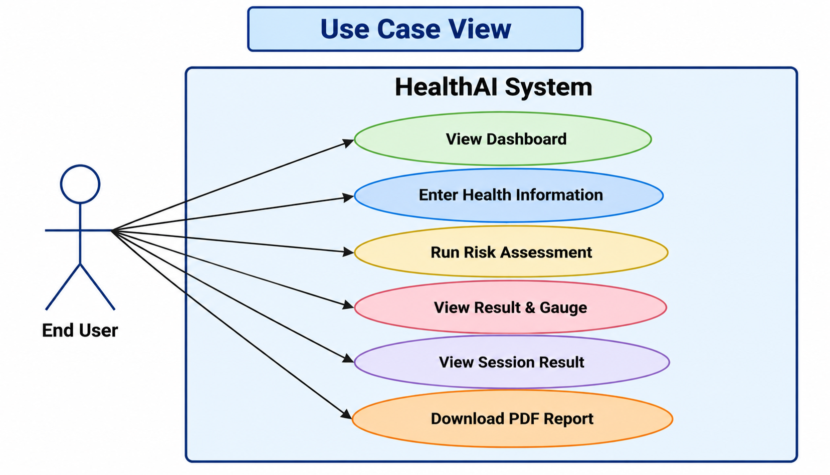
Figure 3. HealthAI use case diagram.
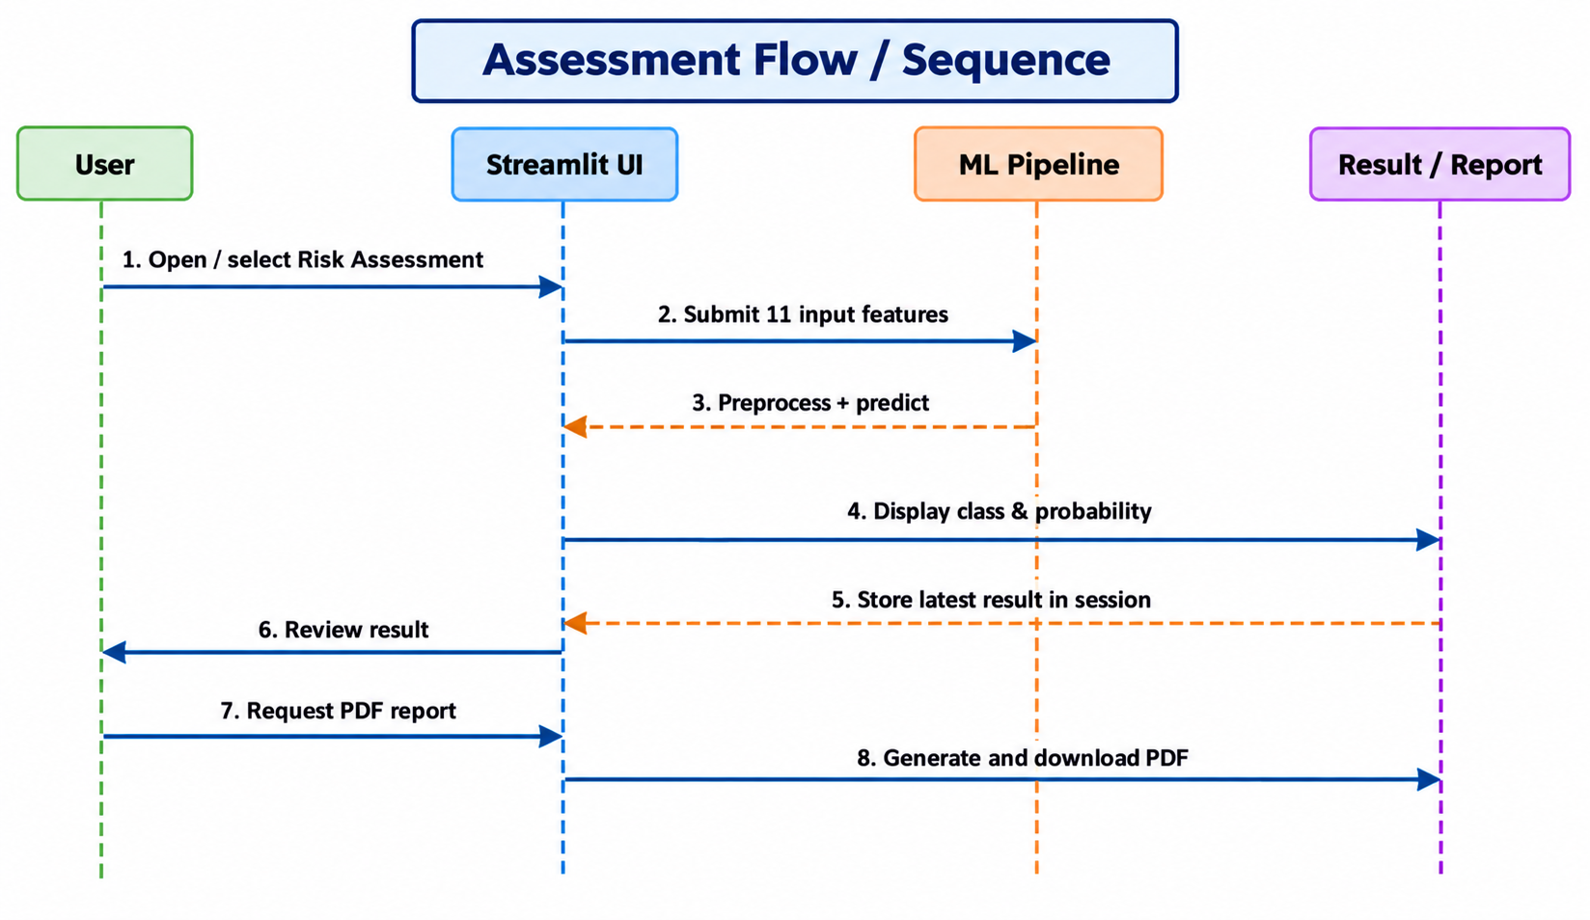
Figure 4. HealthAI assessment flow / sequence diagram.
7. Academic Review & Sign-Off
This Software Requirements Specification document has been submitted and reviewed by the academic supervisory panel:
Project Coordinator / Guide | Internal Examiner | Head of Department (HOD)
Signature: __________________  Date: __________________ | Signature: __________________  Date: __________________ | Signature: __________________  Date: __________________

